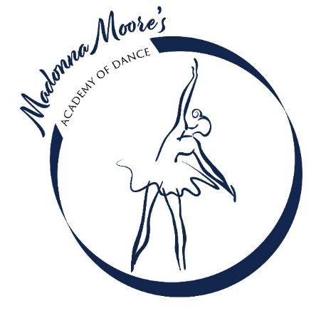

Enrolment Form

2024

|  |  |
| --- | --- |
| CHILD’S NAME |  |
| CLASS ENROLLED IN |  |
| SCHOOL YEAR |  |
| PARENTS/GUARDIANS |  |
| PHONE NUMBERS |  |
| EMAIL ADDRESS |  |
| EMERGENCY CONTACT AND PHONE NUMBER |  |
| ALLERGIES/MEDICAL CONDITIONS ETC |  |

If there are any child safety issues that would affect pick-up from dance (ie if we need to be aware that your child should not go home with a particular person etc) please contact me directly.

Please email form to [madonnamooredance@gmail.com](mailto:madonnamooredance@gmail.com) or print and give to your teacher